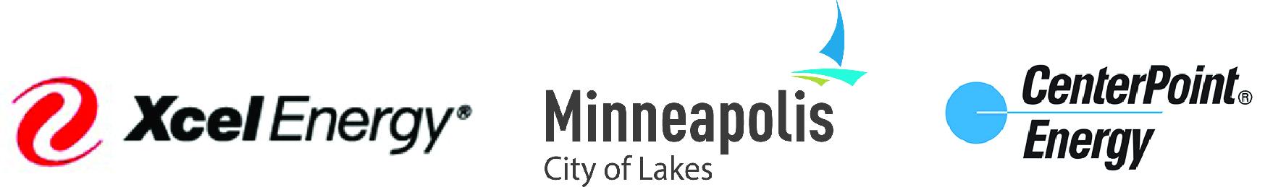

Clean Energy Partnership Board Meeting

Date: Friday, November 4, 2016
Location: Xcel Energy 414 Nicollet Mall (the original building), Lower Level Bay 1
Time: 1:00 – 3:00 pm

Agenda

1. Welcome & Introductions 1:00
CenterPoint Energy announces Board membership changes

2. Review and approve Agenda and Minutes 1:05
(Attachment A – September 16 CEP Board Meeting Minutes)

3. 2017-2018 Energy Vision Advisory Committee (EVAC) 1:15
Recognize new and reappointed members
Thank you to departing 2015-2016 members

5. 2017-2018 Work Plan Discussion 1:25
- EVAC Recommendations for 2017-2018 Work Plan (Weber)
- Board Roundtable Discussion

Board members individually identify their #1 priority for the Partnership in 2017-2018, followed by a group discussion.

6. Next Meeting: Jan 26, 2017, Location TBD 2:25
- Vote to adopt the 2017-2018 Work Plan
- Update on EE Community Engagement Pilot
- New Chair and Vice Chair appointments
Expect to receive more info from your staff prior to the next meeting.

7. Announcements / Open Discussion 2:30

8. Adjourn 3:00

