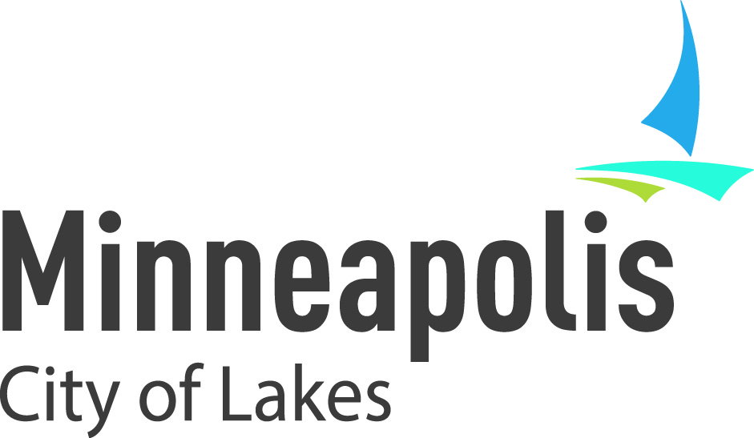
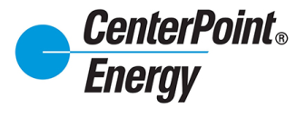

Planning Team Updates
for Q3 EVAC Meeting
Community Engagement for Energy Efficiency – Pilot Project
The release of a Request for Proposals (RFP) issued by the City is expected in the first half of September. With a total of $30,000, the Clean Energy Partnership anticipates funding 1-3 projects.

Cities Leading through Energy Analysis and Planning (Cities-LEAP)
The Clean Energy Partnership (CEP) applied for a $500,000 federal Department of Energy grant to enhance data gathering and community outreach related to the CEP’s upcoming pilot project. Significant time and effort was spent producing a solid application with extra points awarded for the City as a White House designated Climate Action Champions. Unfortunately, we were not selected for funding.

Clean energy community award nomination
The CEP has been selected as a finalist for the first annual Minnesota Department of Commerce’s Clean Energy Community Awards program! The applications are being reviewed, and up to five award recipients will be selected by mid-September, with an award program to be held in October. https://mn.gov/commerce/industries/energy/efficiency/cec.jsp

MINNEAPOLIS COMMUNITY SOLAR GARDEN RFP
The City extended the deadline until August 31 for proposals related to Community Solar Garden subscription (including potential ownership of renewable energy credits). Note: Brian Millberg, the City’s energy manager, is leaving after seven years. http://www.minneapolismn.gov/finance/procurement/rfp

CITY FUNDED FREE HOME ENERGY SQUAD VISITS AND 0% FINANCING FOR INCOME QUALIFIED RESIDENTS
A utility bill insert will go out in September promoting the program. There have been 94 visits and three loans closed to date. Https://www.mncee.org/hes/minneapolis/

CENTERPOINT ENERGY BUILDING EARNS LEED SILVER CERTIFICATION
After a complete redesign and renovation of the former Neiman Marcus building, the new CenterPoint Energy building has earned Leadership in Energy and Environment Design Silver certification by the U.S. Green Building Council. LEED is a green building certification program that recognizes best-in-class building strategies and practices globally.

XCEL ENERGY RESIDENTIAL PROGRAM BROCHURE TRANSLATED INTO SPANISH
“It Pays to Save” brochure that lists all residential energy efficiency, renewable energy and low income program service offerings has been translated into Spanish and available for use at events. Ask Bridget for copies.

LUKE HOLLENKAMP IS NEW CITY SUSTAINABILTY PROGRAM COORDINATOR
Luke Hollenkamp, previously with University of Minnesota and Weidt Group, recently joined the Minneapolis Sustainability Office.

