Energy and GHG Snapshot

Figure 1
Minneapolis Greenhouse Gas Emissions (GHGs) from Citywide Activities from 2006-2014
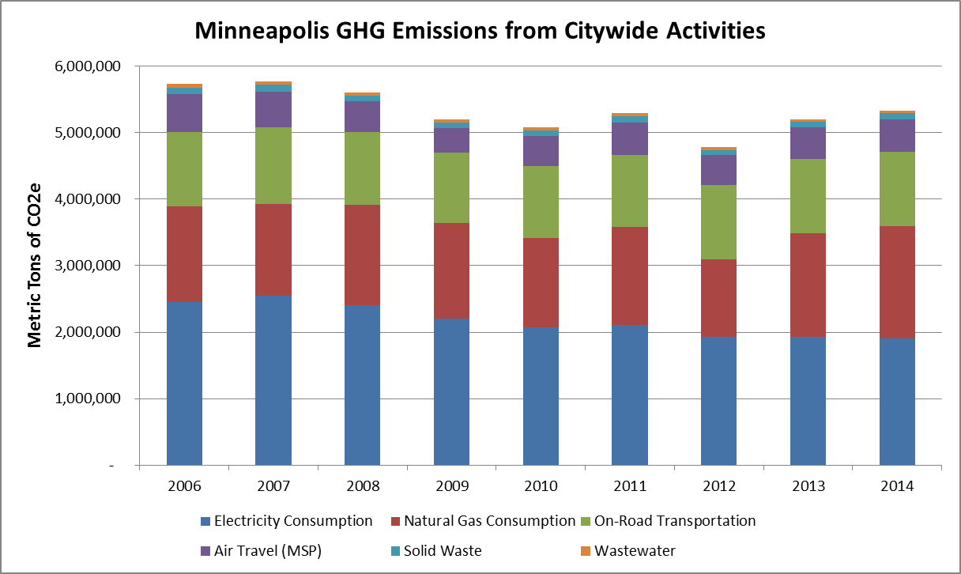

Figure 2
Minneapolis GHGs by Citywide Source for 2014 (most recent year data is currently unavailable)
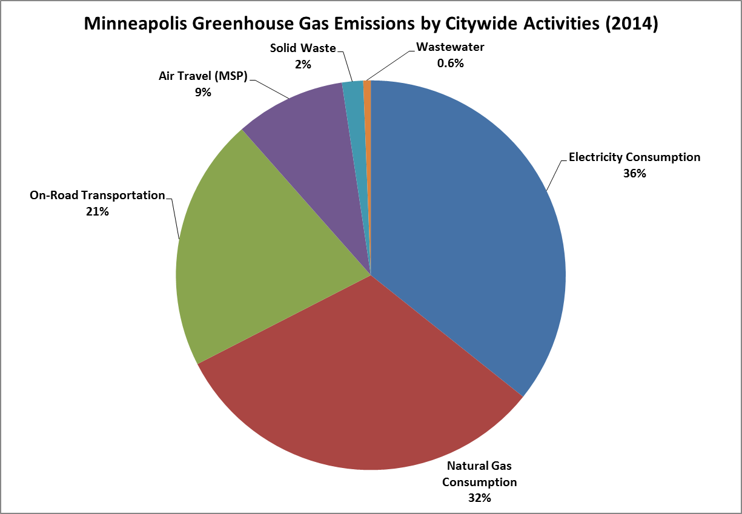

Figure 3
Minneapolis GHGs by Energy Use by Sector for 2014 (most recent year data is currently unavailable)
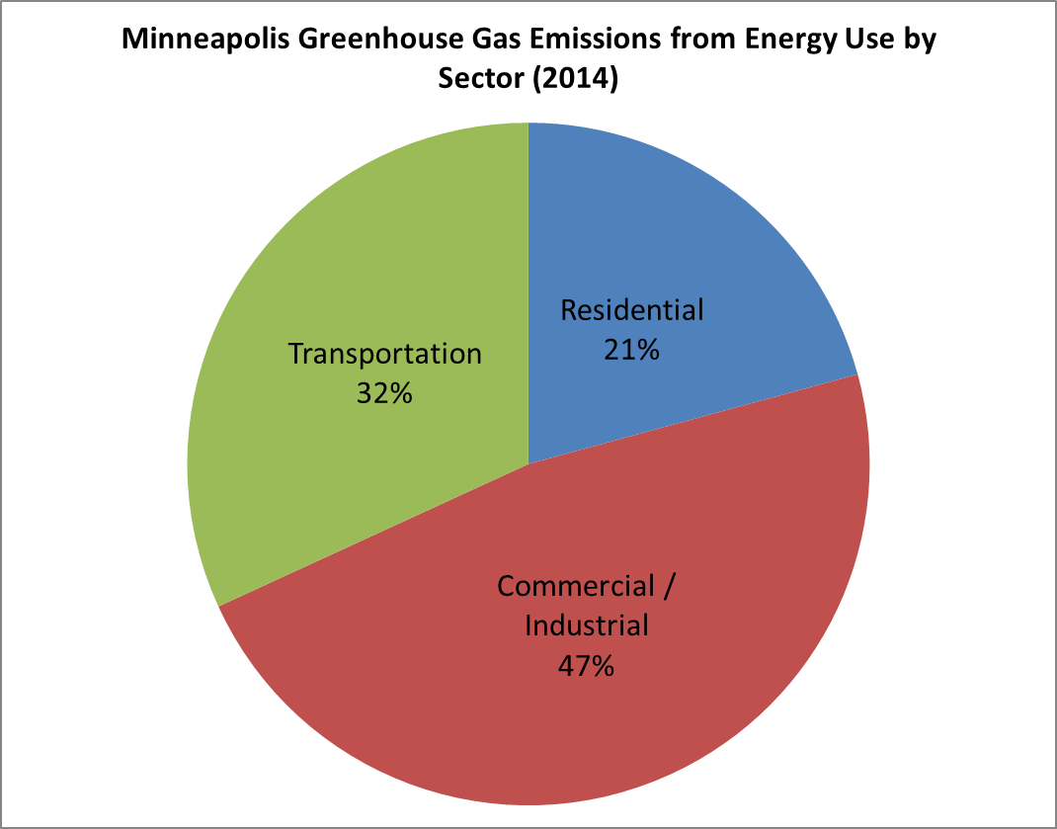

Figure 4
The following chart was created by Siemens using the City Performance Tool (CyPT), a software model that measures the economic and environmental impacts of infrastructure on a city. This is one example of how Minneapolis could reach 80% greenhouse gas emission reductions by 2050. The chart shows annual carbon emissions reductions expected from 40 technologies. For the full report, go to minneapolismn.gov/sustainability/climate-action-goals/CyPT.
